VIRTUAL MOUSE



Session (2019-2022)

Program

Bachelor of Studies in Computer Science

Submitted By:

Muhammad Shujaat 53690-S19

Supervised By:

Dr. Faisal Bahadur

Assistant Professor, Department of Computer Science and IT

Hazara University, Mansehra FINAL

APPROVAL

This is to certify that we have read the project report title ““Virtual Mouse” submitted by the following student of BSCS Hazara University Mansehra:

S. No | Name | Roll No
 | Muhammad Shujaat | 53690-S19

It is out judgment that this project report is of sufficient standards to warrant its acceptance by the Department of CS & IT, Hazara University Mansehra for the award of BSCS Degree.

COMMITTEE

Supervisor Name:

Supervisor Signature:

External Examiner

Chairman CS & IT
DECLARATION

I hereby declare that the work contained in this report is original and has been done by me under the sincere guidance of my project supervisor. I also declare that this project report has not been published and/or submitted for any other degree award to any University before. I further declare that this web application and all associated documents, report and records are submitted as partial requirement for the degree of Bachelor Studies in Software Engineering.

Muhammad Shujaat

ACKNOWLEDGMENT
All glory to ALLAH, the source of knowledge within and beyond comprehension who enabled me to accomplish my goal. First, I express my heartiest thanks and gratefulness to almighty Allah for His divine blessings throughout my project work to complete this project successfully.

I am obliged to pay my sincere and heartiest gratefulness to my supervisor Dr. Faisal Bahadur. His timely guidance and energetic supervision, valuable advice made it possible to complete this project.

I would like to pay my sincere thanks to all my teachers for delivering latest and informative information in the courses during the degree that paved a way for me to improve my skills.

I am also thankful to the staff of University for their Cooperative and assisting behavior throughout.

Last but not the least I express my heartfelt gratitude to my parent for their sincere prayers, selfless support and encouragement that inspired me for all the time. My accomplishments and success are because they believed in me. Deepest thanks to my siblings, whose constant love and support keep me motivated and confident to make this achievement possible.

Preface
Since the computer technology continues to grow up, the importance of human computer interaction is enormously increasing. Nowadays most of the mobile devices are using a touch screen technology. However, this technology is still not cheap enough to be used in desktop systems.
Creating a virtual human computer interaction device such as mouse using a webcam and computer vision techniques can be an alternative way for the touch screen.
Finger tracking based a virtual mouse application Will be designed and implemented using a regular webcam.
The motivation is to create an object tracking application to interact with the computer, and develop a virtual human computer interaction device.
Many researchers in the human computer interaction and robotics fields have tried to control mouse movement using video devices.

DEDICATION

I dedicate this report to Allah the almighty without whom we can do nothing. I further dedicate this to my beloved family and my co-operative and respectful Teachers. Whose affection, love and prayers made me able to complete this project successfully. May Allah bless them with a very happy, successful and a healthy life!

TABLE OF CONTENTS

CHAPTER 1
INTRODUCTION
1.1 Introduction of the Project and its background 2
1.1.1 Brief 2
1.1.2 Project Background 3
1.1.3 Literature Review 3
1.2 Introduction of the Tool used in the Project 4
1.2.1 Libraries 4
1.2.2 Languages 4
1.3 Scope of the Project 4
1.4 Feasibility of the Project 5
1.4.1 Economic 5
1.4.2Technical 5
1.4.3 Operational 5
1.4.4 Hardware & Software available or required 6
1.4.5 Expertise available/required 6
1.4.6 Recurrent Cost Analysis 6
1.5 Introduction of Report 6
CHAPTER 2
PRESENT SYSTEM
2.1 Present System(scenario) 9
2.2 Why we need new system 11
2.3 What are available solutions for the Present issue? 11
2.4 Which one solution you chosen and why? Justification of the Proposed system 12
CHAPTER 3
DESIGN OF THE PROPOSED SYSTEM
3.1 Introduction of Design Document 15
3.1.1 Purpose 15
3.1.2 Scope 15
3.1.3 Compatibility 15
3.1.4 Extensibility 16
3.1.5 Modularity 16
3.1.6 System Architecture 16
3.2 Flow chart of the proposed system 17
3.3 System diagram of the proposed system 18
3.4 Entities involved in the Proposed System 19
3.5 Algorithm of the system 19
3.6 Tool used to build the Proposed System 20
3.7 Justification to use the Proposed System 20
CHAPTER 4
TESTING
4.1 Black box testing 23
4.2 Module testing 23
4.2.1 Unit Testing 23
4.2.2 To accessing camera 23
4.2.3 Color detection code testing 24
4.2.4 Integration Testing 26
4.2.5 System testing 27
4.2.6 Test Cases 28
4.2.7 Automated Testing 30
4.3 Branch Testing 30
4.3.1 Use Case Access Camera 30
4.3.2 Use Case Movement 32
4.3.3 Use Case Drag 33
4.3.4 Use Case Drop 34
4.4 Results validations 35
4.4.1 COMPARING WITH PREVIOUS MODELS 37
4.5 Conclusions 38
4.5.1 Limitations 39
4.5.2 Future Work 40
4.5.3. Tools used 40
CHAPTER 5
RESULTS OR SCREEN SHOTS
5.1 Real-time optical image capture 42
5.1.1 Execution of Mouse Action 42
5.1.2 User Interface 46
CHAPTER 6
REFERENCE MANUAL OR TRAINING MANUAL
6.1 References 48

List of Tables

Table 4.2.4 Integration test case 9
Table 4.2.6 (I) Testing video capturing 10
Table 4.2.6 (II) Detecting Object 11
Table 4.2.6 (III) Joints between object 12
Table 4.2.6 (IV) Mid points 15
Table 4.2.6 (V) Movement of curser 26
Table 4.3.1 Camera Access Scenario 28
Table 4.3.2 Movement 33
Table 4.3.3 Drag Scenario 33
Table 4.3.4 Drop Scenario 34

List of Figures
Fig 2.1.1 Current mouse 4
Fig 2.1.2 Mechanical mouse 6
Fig 2.1.3 Optical and laser mouse 7
Fig 3.1.6 Architectural diagram 7
Fig 3.2 Flowchart of proposed system 8
Fig 3.3 System Flow Diagram 15
Fig 4.4 Accuracy of Mouse Operation 18
Fig 4.4.1 Compression Graph 18
Fig 5.1 Accessing and Capturing Video 19
Fig 5.1.2 Main Page 20
Fig 4.6.2 Accessing Capturing Video 25
Fig 5.3.1 Main Page 28

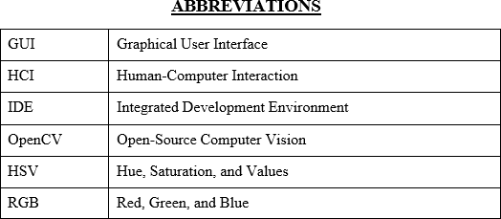

CHAPTER 1

INTRODUCTION

1.1 Introduction of the Project and its background

With the development technologies in the areas of augmented reality and devices that we use in our daily life, these devices are becoming compact in the form of Bluetooth or wireless technologies. This paper proposes an AI virtual mouse system that makes use of the hand gestures and hand tip detection for performing mouse functions in the computer using computer vision. The main objective of the proposed system is to perform computer mouse cursor functions and scroll function using a web camera or a built-in camera in the computer instead of using a traditional mouse device. Hand gesture and hand tip detection by using computer vision is used as a HCI [1] with the computer. With the use of the AI virtual mouse system, we can track the fingertip of the hand gesture by using a built-in camera or web camera and perform the mouse cursor operations and scrolling function and also move the cursor with it.

While using a wireless or a Bluetooth mouse, some devices such as the mouse, the dongle to connect to the PC, and also, a battery to power the mouse to operate are used, but in this paper, the user uses his/her built-in camera or a webcam and uses his/her hand gestures to control the computer mouse operations. In the proposed system, the web camera captures and then processes the frames that have been captured and then recognizes the various hand gestures and hand tip gestures and then performs the mouse function.
Python programming language is used for developing the AI virtual mouse system, and OpenCV which is the library for computer vision is used in the AI virtual mouse system. In the proposed AI virtual mouse system, the model makes use of the Media Pipe package for the tracking of the hands and for tracking of the tip of the hands, and also, Pynput, Autopy, and PyAutoGUI packages were used for moving around the window screen of the computer for performing functions such as left click, right click, and scrolling functions. The results of the proposed model showed very high accuracy level, and the proposed model can work very well in real-world application with the use of a CPU without the use of a GPU.

1.1.1 Brief
Developing a digital mouse that works with a webcam is the focus of this work. In this study, we employ a camera to take continuous pictures of the user's hands, which are then processed to simulate mouse clicks. This means that we can give the computer commands without really touching it or moving any hardware
OpenCV is an open-source collection of computer vision programming tools designed for use in real-time. In the beginning, it was created by Intel, but subsequently, Willow Garage and Its EEZ began to back it. The library is available under the freely distributable Apache 2 License, and it works across several platforms.
Python is an interpreted high-level programming language that may be used for a wide variety of purposes. The concept behind Python's design emphasizes code readability, as seen by the language's liberal use of indentation.
Python shell Python language is an interpreter. When you only want to run one Python command and see its output, you may utilize Python's built-in Python Shell. By reading the command, evaluating it, printing the result, and then looping back to read the command again, this process is also known as REPL (Read, Evaluate, Print, Loop).

1.1.2 Project Background
The purpose of the project is to create a virtual mouse that works with the help of a web camera. In this project, a camera continuously takes images of hand movements of a user, which is then mapped into mouse inputs. This means that we can give inputs to computer without having any physical connection with the computer and without having any hardware movements.

1.1.3 Literature Review
GUI Graphical User Interface
HCI Human Computer Interaction
IDE Integrated Development Environment
OpenCV Open Source Computer Vision
HSV Hue, Saturation, and Values
RGB Red, Green, and Blue

1.2 Introduction of the Tool used in the Project

1.2.1 Libraries
- Opencv
- HandTrackingamodule
- Numpy
- Autopy
- pyautogui

1.2.2 Languages
- Python

1.3 Scope of the Project
The future scope of an AI virtual mouse python project can be quite broad, as the technology has many potential applications. Here are a few possibilities:
- Assistive technology: The virtual mouse could be used to assist people with disabilities, allowing them to control their computers more easily.
- Robotics: The virtual mouse technology could be used in robots to enable them to interact with computers and other electronic devices.
- Gaming: The virtual mouse could be used to control characters or objects in video games, allowing for more immersive gameplay.
- Automation: The virtual mouse could be used to automate repetitive tasks such as data entry, saving time and reducing errors.
- Remote control: The virtual mouse could be used to remotely control other devices, such as smart home devices or drones, from a computer.
- Image recognition: The virtual mouse could be used to recognize images on the screen and automate tasks accordingly.
- Human-computer interaction: The virtual mouse could be used to develop more natural and intuitive ways for people to interact with computers.
- Augmented Reality: The virtual mouse could be integrated in AR apps to interact with virtual elements in the real world
Overall, the future scope of the AI virtual mouse python project is quite broad, as the technology has the potential to be used in a wide range of industries and applications.

1.4 Feasibility of the Project
The following steps were followed during the feasibility analysis:

    - Recognize information at various levels.
    - Determine the user's expectations.
    - Assess the significance of a prototype.

1.4.1 Economic

This idea is economically viable in every way since it requires less work, less time, and just a little investment in equipment to construct the prototype.

1.4.2Technical
A basic platform may be used to create the system. All of the communication functions of a project may be integrated into the new system. As a result, the system is technically possible.

1.4.3 Operational
This system is fully functioning and ready for implementation. Virtual Mouse is simple to use not just for advanced users but also for inexperienced ones. It creates a basic environment in which people may feel free to operate more quickly, easily, and precisely. As a result, it is socially and behaviorally acceptable, as well as practicable

1.4.4 Hardware & Software available or required
The hardware requirements for this project would be a computer with a compatible operating system (Windows, macOS, or Linux), webcam and Python 3.8 installed.

1.4.5 Expertise available/required
To develop an AI virtual mouse python project, a developer would need expertise in Python programming and experience using the PyAutoGUI library. In addition, expertise in image recognition, computer vision and GUI automation would be beneficial.

1.4.6 Recurrent Cost Analysis
The recurrent cost for this project would be minimal, as the PyAutoGUI library is open-source and freely available. Once the project has been developed and implemented, there would be minimal ongoing costs associated with maintaining and updating the technology. However, costs may be incurred for any additional software and hardware that is needed to support the project and its implementation.

1.5 Introduction of Report
Chapter 1:
- This chapter provides an overview of the AI Virtual Mouse project, including the problem statement, project objectives, and significance of the project.
Chapter 2:
- This chapter reviews the existing literature on AI virtual mouse and related topics, including research on computer vision, machine learning, and human-computer interaction.
Chapter 3:
- This chapter describes the methods and techniques used in the project, including the development of the AI algorithm, data collection, and evaluation methods.
Chapter 4:
- This chapter presents the results of the project, including a detailed analysis of the performance of the AI virtual mouse, and discusses the implications of the results for future research.

Chapter 5:
- This chapter summarizes the key findings of the project and discusses potential future directions for research in AI virtual mouse technology.

CHAPTER 2

PRESENT SYSTEM

2.1 Present System(scenario)

In this chapter we discuss about the present system of mouse. It is known that there are various types of physical computer mouse in the modern technology, the following will discuss about the types and differences about the physical mouse. A Computer Mouse is an input device that helps to point and to interact with whatever that is being pointed. There are so many types of mouse in the current trend, there’s the mechanical mouse that consists of a single rubber ball which can rotate in any direction and the movement of the pointer is determined by the motion of that rubber ball.

2.1.1 Current System
The current system has the following flaws:

      - Typically, less precise than using a mouse
      - Track balls' ball mechanisms need more regular cleaning than a mouse's.
      - Inconveniently designed, to put it mildly
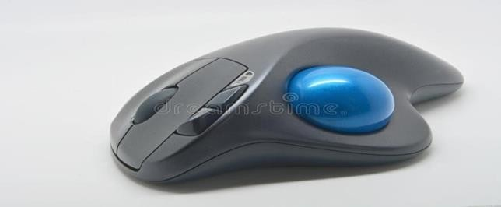
Figure 2.1.1

2.1.2 Mechanical Mouse
      - Cannot deliver superior efficiency
      - Requires a certain surface to work
      - Takes up more desk space than a trackball.
      - The mouse rollers and button switches are prone to wear and breakdown, which may lead to malfunction. Requires a flat surface to operate.

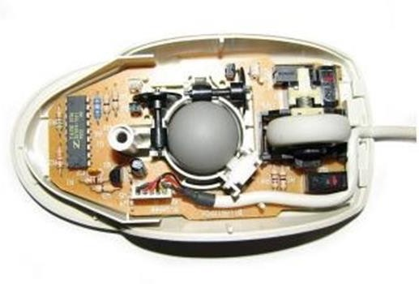

Figure 2.1.2: Mechanical mouse

2.1.3Optical and laser mouse
      - Prone to button switches degradation.
      - Does not function properly while on a polished surface
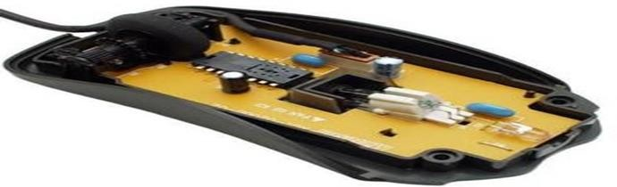

Figure 2.1.3: Optical and laser mouse

2.2 Why we need new system
There are some reasons to propose new system like covid19 situation by eliminating the human intervention and dependency of devices to control the computer. There are some limitation of present system.
2.2.1 Limitations of the Present system

• The existing systems are our traditional hardware mouse devices either wired or wireless to control the cursor. This means the actual hardware device is required. Also, the touchpad in laptops and touch screen devices requires a user to touch the surface.
• Other existing virtual mouse control system consists of a simple mouse operation which uses colored tips like red, green, and blue color. These colored fingers act as an object that the web-cam senses to perform actions and then image processing techniques are applied to them.
• Some existing systems use number of fingers to perform the specific operations (for e.g. 1 finger for left click, 2 fingers for right-click, 3 for double click). Such systems are more complex and difficult for the user to use.

2.3 What are available solutions for the Present issue?
The available solution for the present issue is the AI virtual Mouse.AI virtual mouse is a computer program or software that simulates the functions of a physical mouse on a computer screen. It allows users to interact with their computer using a mouse cursor, just as they would with a physical mouse. Virtual mice are commonly used in touchscreens and other devices without physical mouse inputs. As the technology increase everything becomes virtualized. Such as speech recognition, Speech Recognition is used for recognition and translation of the spoken language into text. Thus, Speech Recognition can replace keyboards in the future, Similarly Eye Tracking which is used to control the mouse pointer with the help of our eye. Eye Tracking can replace mouse in the future. Gestures can be in any form like hand image or pixel image or any human given pose that require less computational difficulty or power for making the devices required for the recognitions to make work. Different techniques are being proposed by the companies for gaining necessary information/data for recognition handmade gestures recognition models. Some models work with special devices such as data glove devices and color caps to develop a complex information about gesture provided by the user/human.
2.3.1 Advantages:
  - Virtual Mouse using Hand gesture recognition allows users to control mouse with the help of hand gestures.
  - System’s webcam is used for tracking hand gestures.
  - Computer vision techniques are used for gesture recognition. OpenCV consists of a package called video capture which is used to capture data from a live video.
  - main thing we need to identify are the applications the model is going to develop so the development of the mouse movement without using the system mouse

2.4 Which one solution you chosen and why? Justification of the Proposed system
A virtual mouse can be chosen for several reasons:
- Accessibility: For individuals with physical disabilities or injuries, a virtual mouse can provide an alternative way to control a computer cursor and access the computer's features without the need for a physical mouse.
- Increased Efficiency: Depending on the specific needs of the user, a virtual mouse can be configured in a way that allows for quicker and more efficient use of the computer.
- Comfort: Some users may find that using a virtual mouse is more comfortable than using a physical mouse, particularly for extended use.
- Cost-effective: A virtual mouse can be a cost-effective solution for those who may not be able to afford a physical mouse or may have difficulty finding a physical mouse that is suitable for their needs.
- Versatility: Virtual mouse software can be configured to work with a variety of input methods, such as a joystick or touchpad, which can provide additional flexibility for the user.

Overall, the choice of a virtual mouse will depend on the specific needs and preferences of the user. It is important to consider factors such as accessibility, efficiency, comfort, cost, and versatility when choosing a virtual mouse solution.

CHAPTER 3

DESIGN OF THE PROPOSED SYSTEM

3.1 Introduction of Design Document
The purpose of a software designer creating a software design description (SDD) is to provide a software development panel with an overview of the software project's structural design in written form. To offer comprehensive feature specifications of minor aspects of the design, an SDD is often utilized in combination with a structural design diagram. The explanation is necessary to rally a large group of people behind a shared goal, to act as a continual reference, and to outline all parts of the application and how it will perform.
The design activity provides a roadmap for gradually translating the demand across various stages into the final product by outlining the structure of the system to be produced.

3.1.1 Purpose
A prototype starts with a solid design. The design is contingent on the software designer's vision and strategy for the proposed system, which in turn is based on the designer's research and comprehension of the existing system. Three distinct sections may be used to break up the design.
      - Input Design
      - Output Design

3.1.2 Scope

When creating a prototype, there are numerous factors to think about. The software's intended purpose and intended user experience should inform the relative weight of each factor. Included in this category are:

3.1.3 Compatibility
The prototype can operate with other operating systems. For example, Windows Mac OS, etc.

3.1.4 Extensibility
The prototype may have new features added to it without requiring a complete redesign

3.1.5 Modularity
There are a lot of moving parts to consider while making a prototype. The proportional importance of each aspect should be determined by the software's goals and the desired user experience. These things include:

3.1.6 System Architecture

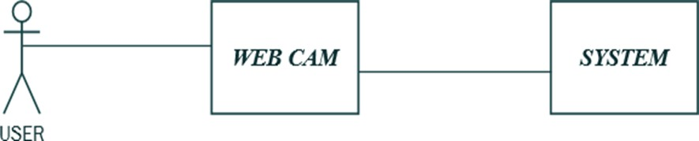

Figure 3.1.6: Architectural diagram

3.2 Flow chart of the proposed system

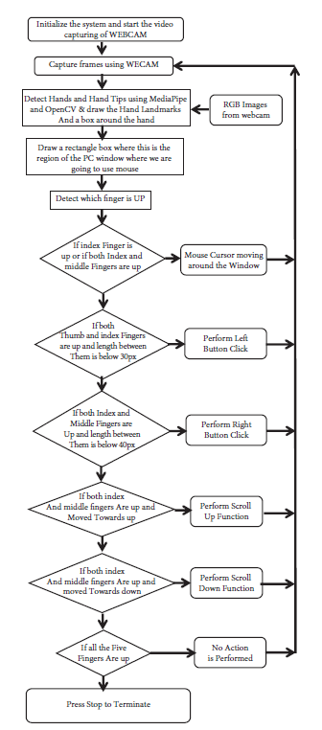
Figure 3.2 flow chart of proposed system

3.3 System diagram of the proposed system

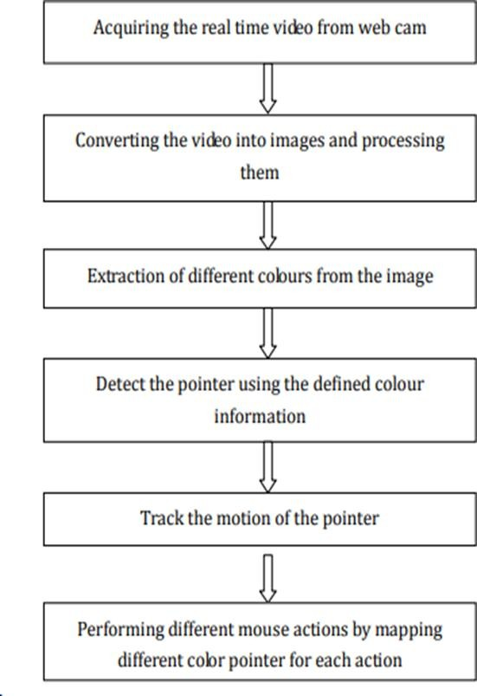
Figure .3.3: system flow diagram

3.4 Entities involved in the Proposed System
- User
- webcam
- Computer/laptop

3.5 Algorithm of the system
Start Program

Initialize the system
start video capturing of Webcam
Webcam used for capturing frames

Detect Fingers and Fingers Tips Using OpenCV
Draw a box around the hand
Taking RGB Images from webcam
Draw a rectangle box where we use mouse

Detect finger by creating midpoint between them

Move finger
Mouse cursor moving

If both finger is touched Perform Click

Use right and thumb finger Perform right click

Thumb finger and right finger join Open folder

Close Webcam End Program

3.6 Tool used to build the Proposed System
The tools used to build the proposed system of an AI virtual mouse Python project may include:
- Python programming language: This is the primary tool used for developing the AI virtual mouse software.
- Libraries and modules: These include libraries such as OpenCV, TensorFlow, or Mediapipe, NumPy which are used for image processing, machine learning, and neural network development.
- Integrated Development Environment (IDE): This is a software application used for writing, debugging, and testing code. Some popular IDEs for Python development include PyCharm, , and Visual Studio Code.
- Version Control System (VCS): This is a tool used to track changes made to the code and collaborate with other developers. Some popular VCS tools include Git, Mercurial, and Subversion.
- Dataset: The dataset used to train the AI virtual mouse, which will be used to recognize hand gestures and movements and translate them into cursor movement.
- Testing Framework: A tool to test the AI virtual mouse, such as pytest or unittest.
- Hardware: The input device, such as a webcam or a leap motion sensor, and output device, such as a computer, used for the AI virtual mouse.

3.7 Justification to use the Proposed System
There are several reasons to justify the use of the proposed system of an AI virtual mouse Python project:
- Accessibility: The AI virtual mouse can provide an alternative input method for individuals with physical disabilities, such as those who are unable to use a traditional mouse.
- Convenience: The AI virtual mouse can be used as a convenient input method for those who prefer to use hand gestures instead of a physical mouse.
- Efficiency: The AI virtual mouse can be more efficient than a traditional mouse, as it can recognize hand gestures and movements more quickly and accurately.
- Customization: The AI virtual mouse can be customized to recognize different hand gestures and movements, making it more versatile than a traditional mouse.
- Cost-effective: The AI virtual mouse can be more cost-effective than traditional input devices, such as special needs mouse,
- Compatibility: The AI virtual mouse can be used with a variety of computer platforms and operating systems, making it more versatile than traditional input devices.
- Functionality: The AI virtual mouse can be integrated with other software and hardware to provide additional functionality, such as voice commands and gesture recognition.
- Machine Learning: The use of machine learning algorithms to train the AI virtual mouse can improve its accuracy and responsiveness over time.

CHAPTER 4

TESTING

4.1 Black box testing
In black box testing, also known as "Behavioral Testing," the tester does not understand the internals of the product being evaluated. These examinations could or might not be accurate, but in general they are. Here are some methods that can be used to make black-box tests:
Equivalence by partitioning input values into valid and invalid groups, and then selecting test data from each group, partitioning is a technique for building software tests. When developing software tests, Boundary Value Analysis is used to determine the input value bounds and then choose test values that lie on, near, or beyond those bounds.

4.2 Module testing
Module testing is a type of software testing where individual units or components of the software are tested. The purpose of module testing is to isolate a section of code and verify its correctness. Module testing is usually performed by the development team during the early stages of software development

4.2.1 Unit Testing
A unit test is the smallest part of an application that can be tested. This could be a function, a class, a procedure, or an interface. Unit tests are written and run by software developers to make sure that the code works as expected and matches its design and requirements. Each part of this VM prototype is also tested. We broke modules into smaller parts and then tested each part on its own for mistakes, performance, efficiency, and response time.

4.2.2 To accessing camera
import cv2

cap=cv2.VideoCapture(0)

while True:

ret,img=cap.read()

cv2.imshow('webcam',img)

k=cv2.waitKey(10)

if k==27:

break; cap.release()

cv2.

4.2.3 Color detection code testing

imgHSV= cv2.cvtColor(img,cv2.COLOR_BGR2HSV)

create the Mask

mask=cv2.inRange(imgHSV,lowerBound,upperBound)#morphology

maskOpen=cv2.morphologyEx(mask,cv2.MORPH_OPEN,kernelOpen)

maskClose=cv2.morphologyEx(maskOpen,cv2.MORPH_CLOSE,kernelClose)

maskFinal=maskClose

conts,h=cv2.findContours(maskFinal.copy(),cv2.RETR_EXTERNAL,cv2.CHAI N_APPROX_NONE)

if(len(conts)==2): if(pinchFlag==0):

pinchFlag=1 mouse.release(Button.left)

x1,y1,w1,h1=cv2.boundingRect(conts[0])

x2,y2,w2,h2=cv2.boundingRect(conts[1])

cv2.rectangle(img,(x1,y1),(x1+w1,y1+h1),(255,0,0),2)

cv2.rectangle(img,(x2,y2),(x2+w2,y2+h2),(255,0,0),2) cx1=x1+w1/2

cy1=y1+h1/2 cx2=x2+w2/2 cy2=y2+h2/2

cx=(cx1+cx2)/2 cy=(cy1+cy2)/2

cv2.line(img, (int(cx1), int(cy1)), (int(cx2), int(cy2)), (255, 0, 0), 3,4)

#cv2.line(img, (cx1,cy1), (cx2,cy2),(255,0,0),2)

#cv2.circle(img, (cx,cy),2,(0,0,255),2)

mouseLoc=(sx-(cx*sx/camx), cy*sy/camy) mouse.position=mouseLoc

#mouse.position!=mouseLoc

#while mouse.position!=mouseLoc:

# pass

#cv2.circle(img, (cx,cy),2,(0,0,255),2)

mouseLoc=(sx-(cx*sx/camx), cy*sy/camy) mouse.position=mouseLoc

#mouse.position!=mouseLoc

#while mouse.position!=mouseLoc:

# pass

#cv2.circle(img, (cx,cy),2,(0,0,255),2)

mouseLoc=(sx-(cx*sx/camx), cy*sy/camy) mouse.position=mouseLoc

#mouse.position!=mouseLoc

#while mouse.position!=mouseLoc:
# pass

4.2.4 Integration Testing
When it comes to software testing, "Integration Testing" is the method through which individual components are combined and evaluated as a whole. The purpose of this kind of testing is to uncover problems with the interplay between different components.
Examples of Integration Test Cases for the Following

    - Moving the cursor
    - You can drag
    - Drop function
Table 4.2.4: Integration Test case

No. | Test case/Test script | Expected result | Result
1. | Check the  movement along with the drag  function | Move and drag the icon | Icon dragged successfully
2. | Check the  movement along with the drop  function | Move and drop the icon | Icon dropped successfully

4.2.5 System testing
After the system has been built, the next step is to test it. Even if the correct algorithms are used to build the system, it may not be reliable. To make the system acceptable, it is very important to check the results. Before putting the system to work, it needs to be checked to make sure that it is completely within its limits and gives the right results.
Implementation means putting into practice the new system. It could mean putting the whole computer system in place or just putting in one small part of it. One of the most important things to do is to change a manual system into a computerized data processing system.
The implementation phase of our project is the time between when the test design is approved and when it works well with the help of a user and operation manual.
After the coding competition, review the prototype and make sure that all events, procedures, outputs, inputs, and movements have been checked. We check the detection to make sure it works, the recognition to make sure it's done on time, and the report information for mistakes. Testing starts with each part and moves toward putting the whole computer-based system together
There are different goals and aims for testing. Here are the most important goals of testing: Finding any mistakes that the programmer might make while making the prototype. Getting people to trust and telling them about the level of quality. To prevent defects.

4.2.6 Test Cases
Windows name: Accessing the camera UCNo: 01 User Name
Valid: {video capture} Invalid: Empty

Table .4.2.6 I: testing video capturing

Test Case  ID | Input | Use case Format | Expected  Output | Actual Output
01 | Video  Frame | {mp4} | Capture video | Capture video

UCNo: 02 detecting objects Valid: {color detections} Invalid: noise

Table 4.2.6 II: detecting objects

Test Case  ID | Input | Use case Format | Expected  Output | Actual Output
01 | Color | {mp4} | Detecting color | Detecting color

UCNo: 03 joints between objects/color Valid: {creating a line}
Invalid: empty
Table 4.2.6 III: joints between object/color

Test Case  ID | Input | Use case Format | Expected  Output | Actual Output
01 | Color | {mp4} | Creating a line  between objects | Creating a line  between objects

UCNo: 04 midpoint Valid: {creating mid-point} Invalid: empty

Table 4.2.6 IV: midpoint of the line

Test Case  ID | Input | Use case Format | Expected  Output | Actual Output
01 | color | {mp4} | Finding a  midpoint on line | Creating a midpoint  on line

UCNo: 05 cursor movement Valid: {cursor movement along with midpoint} Invalid: empty

Table 4.2.6.V: movement of the cursor

Test Case  ID | Input | Use case Format | Expected  Output | Actual Output
01 | Color | {mp4} | Cursor  movement | Cursor movement

4.2.7 Automated Testing
Automated checking out is the execution of your test plan (the components of your utility you need to check, the order in which you need to test them, and the anticipated responses) through a script as opposed to a human. Python already comes with a fixed of gear and libraries to help you create computerized checks for your utility.

4.3 Branch Testing
Branch coverage is a testing method, which aims to ensure that each one of the possible branch from each decision point is executed at least once and thereby ensuring that all reachable code is executed.
That is, every branch taken each way, true and false. It helps in validating all the branches in the code making sure that no branch leads to abnormal behavior of the application.

4.3.1 Use Case Access Camera
Table 4.3.1: Camera Access scenarios

Use Case Title | Access camera
Use Case Id | 1
Description: How the user will access the camera
Primary Actor: | User
Pre-Conditions:
1. Prototype is working on runtime.
Post Conditions:
1. Successfully using the prototype.
Authority: user
Modification History: 1.0
Author: Muhammad Shujaat

4.3.2 Use Case Movement
Table 4.3.2: Movement

Use Case Title | Movement
Use Case Id | 2
Description: cursor moves along with the movement of the hand.
Primary Actor | User
Pre-Conditions:
1. User should have a pointed color on the figure.
Post Conditions:
1. Successfully moving the cursor.
Authority: User
Author: Muhammad Shujaat

4.3.3 Use Case Drag

Table 4.3.3: Drag Scenarios

Use Case Title | Drag
Use Case Id | 3
Description: This use case describes the process of dragging the icons.
Primary Actor | User
Pre-Conditions:
1.. User should have a pointed color on the finger.
2. User should have proper finger positions.
Post Conditions:
1. Icons are dragged Successfully.
Authority: User
Modification History: 1.0
Author: Muhammad Shujaat

4.3.4 Use Case Drop
Table 4.3.4: Drop scenarios.

Use Case Title | Drop
Use Case Id | 4
Description: This use case describes the process of dropping the icons.
Primary Actor | User
Pre-Conditions:
1.. User should have a pointed color on the finger.
2. User should have proper finger positions.
Post Conditions:
1. Icons are dropped Successfully.
Authority: user
Modification History: 1.0
Author: Muhammad Shujaat

4.4 Results validations

The proposed model of AI virtual mouse demonstrates the idea of computer vision technology and machine learning capabilities.
For verifying and testing of the proposed AI virtual mouse system only a certain quantity of datasets are attainable. The hand tracking, finger-tip detection and gestures recognition have been performed in various illuminated conditions and at diversified distances from the camera. The results of the testing are given below. The test was performed 25 times by 4 persons resulting in 600 gestures with manual labelling, and this test has been made in different light conditions and at different distances from the screen, and each person tested the AI virtual mouse system 10 times in normal light conditions, 5 times in faint light conditions, 5 times in close distance from the webcam, and 5 times in long distance from the webcam, and the experimental results are tabulated in Table
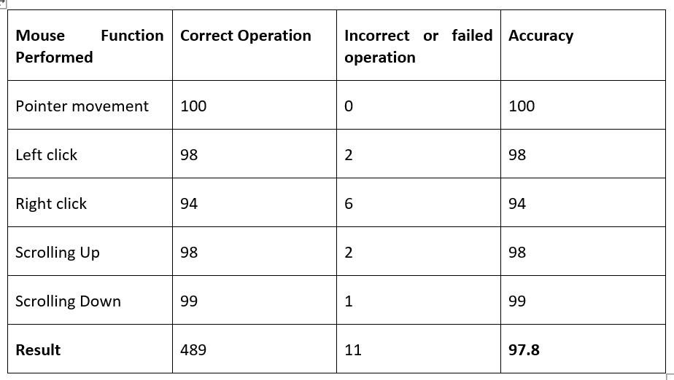

Table 4.4. Accuracy of mouse operations

The following bar graph shows the accuracy of operations that have been observed by testing the model under various illumination conditions and numerous operations. Table 1 shows the comparison between different functions and how they are accurate. Let’s see the accuracy using bar graphs which is one of the most using statical tool used to calculate the function parameters.

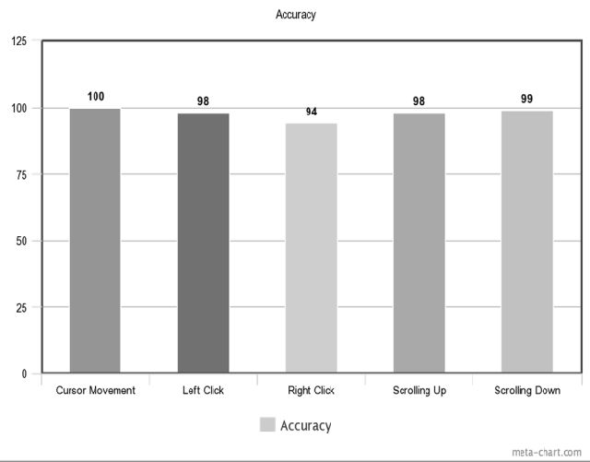

Figure 4.4 Accuracy of mouse operations (Bar Graph)

4.4.1 COMPARING WITH PREVIOUS MODELS

To see how well the proposed model works against previous systems we have compared them and the figure 13 shows the comparison of the AI virtual mouse model with models mentioned in the related models section.
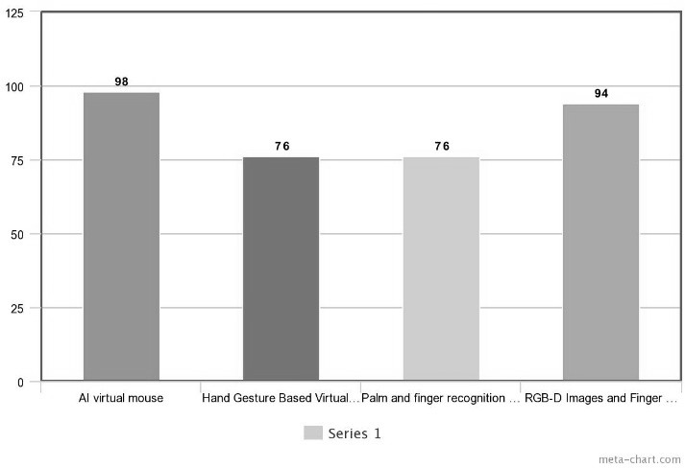

Figure 4.4.1 Comparison graph with other models

4.5 Conclusions
It's not shocking that in the field of (HCI), when all mouse motions may be done with the flick of a finger, the physical mouse will eventually be replaced by a virtual non- physical mouse. Our goal was to develop a color-recognition system that could function as a mouse replacement without compromising on precision or speed. The software is sensitive to color combinations and may translate them into action with the mouse. Accuracy and efficiency are crucial to make the program as helpful as a real mouse, thus a few approaches were required. As a first step, we take an average of the coordinates of the colors that determine the cursor's motions. Given that even a little shift in your hand position might cause the cursor to shift in an unexpected direction, it's important to minimize and stabilize the sensitivity of cursor movements.
Aside from that, a variety of color schemes was included, and the distance between any two colors in a scheme was determined. As the separation between two colors determines whether mouse functions are activated, this was done.
This implementation intends to reduce the complexity of the program's operation. That way, true mouse functions may be activated with little guesswork. Calibrations were also included to help make color tracking more precise and adaptable. Because of this, users may assign whatever color they choose to each mouse button, so long as the colors don't share an RGB value (e.g. blue and sky-blue). Additionally, adaptive calibrations were implemented. As a result, the application may store many sets of HSV values from various perspectives for later use in the identification process. In general, technological advancements have boosted societal efficiency and quality of life. It's not the other way around.
As a result, communities shouldn't cling to antiquated technology while resisting the benefits of more modern innovations. They should instead make adjustments to their habits and routines that will allow them to be more effective and efficient.

4.5.1 Limitations
There are a few issues with this project that can make it difficult to identify colors. One of the issues is the setting in which the recognition stage takes place. The recognition procedure is very light-dependent.
The acquired frames may not have the intended hues if the situation is too light or dark. Besides, distance is another component that might modify the outcomes of color recognition. As the present detecting range only extends out to 25 cm, any color display beyond that distance will be disregarded as background noise. There is a significant hardware dependency on the program's performance.
The effectiveness of the application may, for instance, depend on the processing speed and/or the resolution of the camera. As a result, when both the processing speed and the resolution are poor, it takes more time to process a single frame. Sometimes colors detection often create a minor problem because of same color in background.
Webcam detects those colors which is problem for accuracy so if we are using this we need colorless background. But this is not a big issue we can remove rgb color detection api and used hand gesture process in which the cam detects full hand and all fingers.

4.5.2 Future Work
There are a few things that need to be added or changed to make the application easier to use, more accurate, and more adaptable to different situations. Here are the changes that need to be made and the features that are needed:

4.5.3. Tools used
An algorithm for smart recognition
Due to the fact that the current recognition process only works within a 25cm radius, it needs a drag-and-drop function to increase the distance it can cover. This way, it can automatically change the focus rate based on how far away the user is from the webcam.

Better Performance
Several hardware factors contribute to response time, including the capabilities of the camera, the quantity of RAM, and the processing speed of the system. Therefore, the application may perform better on a high-quality computer equipped with a camera that handles varying levels of illumination with ease.

Adding events for clicking
We didn't have enough time or money to add these features to this project. Because information technology is growing quickly, this industry wants more and more, and we are working hard to add clicking events to virtual mice.
- Left-clicking • Right-clicking

CHAPTER 5

RESULTS OR SCREEN SHOTS

5.1 Real-time optical image capture
The frame is recorded in real-time using (cv2.VideoCapture (0); and then each image is flipped and compressed to a reasonable size using vid cod = cv2.VideoWriter force(*'XVID').

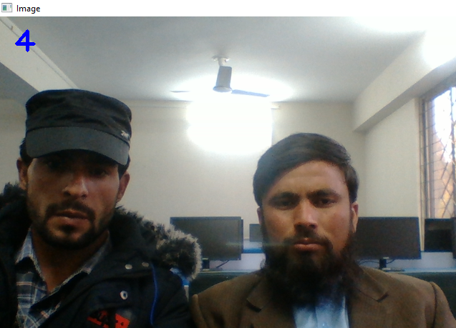
Figure 5.1: Accessing and capturing video

5.1.1 Execution of Mouse Action
The program will conduct mouse activities differ depending on the color combinations that are found in the processed frame. The movements of the mouse will be carried out following the program's coordinates, and the software will continue to collect and evaluate the next real-time image until the user quits the application. The following list describes the color combinations that may be used to trigger and carry out various mouse tasks. for execution and controlling the mouse action, we used a rgb color detection by using red and blue color.
Using a finger caps colors, green and blue. The webcam detects a blue and green to perform actions.
In this project Opencv libraries is used which is used for capturing videos and images rapidly. Similarly, rgb api also used in it which is quietly easy to perform actions.

Table 5.1.1: mouse actions

Sample Layout | Mouse Functions | Color Combinations
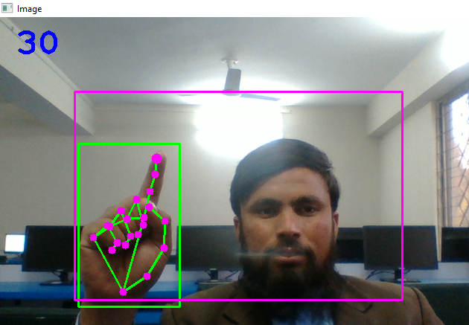 | Move Cursor | First Colors (e.g. Green)
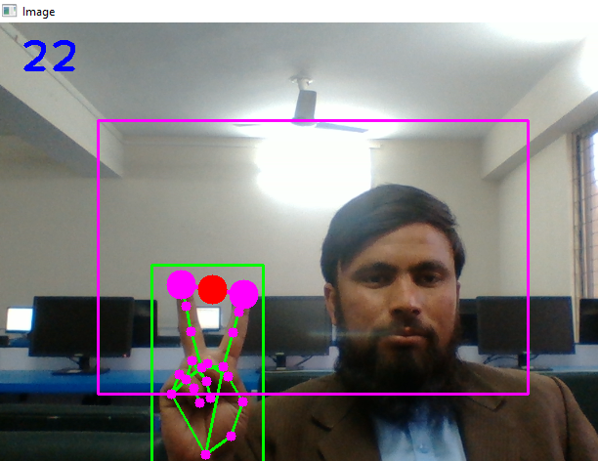 | Drag function | first Color + Second Color (pinch Gesture) (e.g. Blue + Green)
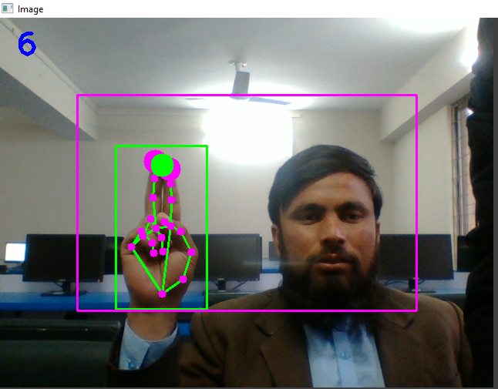 | Drop function | first Color + Second Color (Un-pinch Gesture) (e.g. Blue + Green)

5.1.2 User Interface
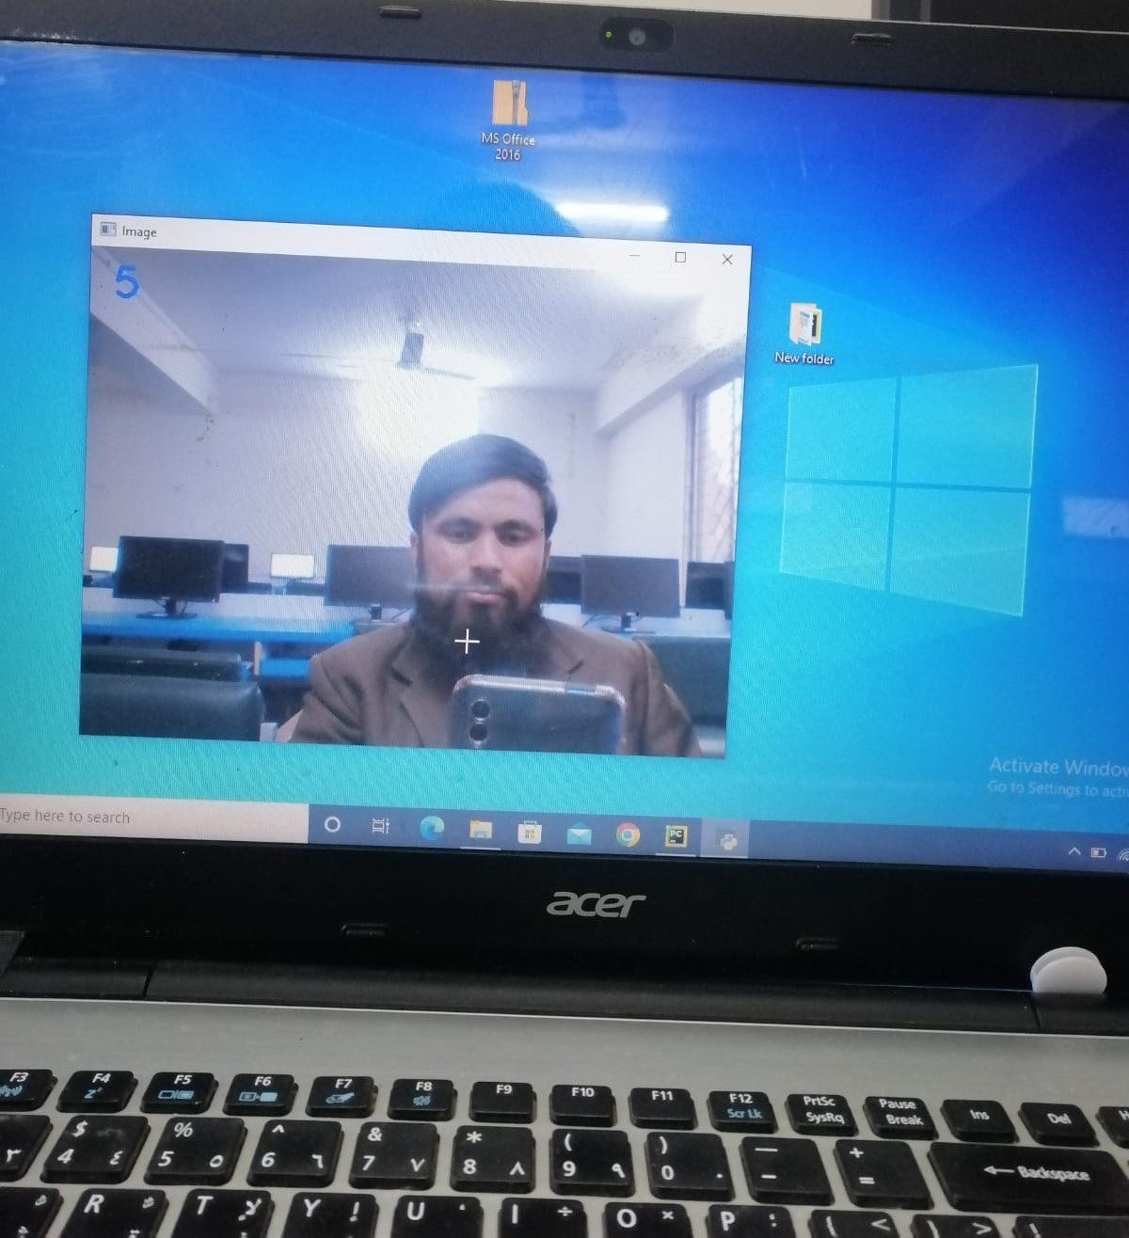
Figure 5.1.2: Main Page

CHAPTER 6

REFERENCE MANUAL OR TRAINING MANUAL

6.1 References
- Kenneth E Kendall & Julie - System Analysis and Design (4th edition).
- Kumar N, M. (2011). Manual Testing: Agile software development. [online] Manojforqa.blogspot.com. Available at: http://manojforqa.blogspot.com/2011/09/agile- software-development.html [Accessed 27 Aug. 2015].
- Activity Diagram https://app.diagrams.net/
- Sequence diagram- https://app.diagrams.net/
- Black box and white box testing - https://www.youtube.com/watch?v=49i26aesGaU
- https://www.youtube.com/channel/UCm9daSbiQK6UoOlXxmr_rnQ
- Park, H. (2008). A method for controlling mouse movement using a real-time camera. BrownUniversity, Providence, RI, USA, Department of computer science.
- https://www.youtube.com/watch?v=8gPONnGIPgw

